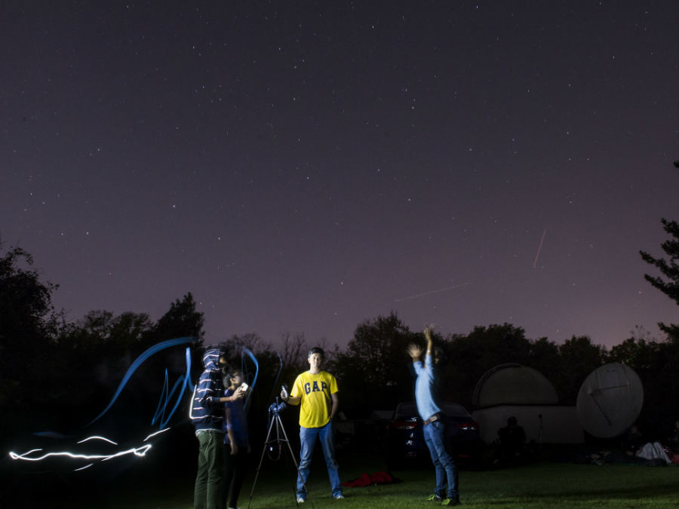

Looking for something spooky and fun to do for Halloween?
Try UFO hunting .... turns out our area is perfect for it
By Ryan Clark
photos by Tim Sofranko

CLEVES, Ohio – In the dark, it was hard to see the entrance to the gravel road. In fact, we had to turn the car around twice to find it.

When we did, we found ourselves in the middle of a parking lot, surrounded by woods. With the car's windows rolled down, we could feel the cool setting in, and the smell of the trees was refreshing. It was 10 p.m.

"Ready?" I asked.

Tim just nodded. It wasn't the first time we'd gone on an expedition looking for something out of the ordinary. We got out and pulled our gear from the trunk.

Just 30 minutes before, we'd set out in a caravan with 50 college students, each interested in looking up at the sky. Of course, we all had different reasons for that.

Most of them were budding scientists; they wanted to see planets and stars and galaxies.

We were journalists hunting for UFOs.

As the college kids packed up their cars, they passed out maps to make sure everyone knew where they were going. As it turns out, few did.

Ishaun Deore, a graduate student in physics at the University of Cincinnati, just smiled at us.

"No one knows exactly where we're going," he said. "But it's supposed to be really easy to get there."

We laughed at that. We thought it summed up our trip – and the whole idea – pretty well.

Just what in the world were we doing, anyway?

The UFO nut

Chuck Zukowski is a bit of a rock star in the world of paranormal investigation. A former sheriff's deputy in Colorado, he started getting reports of strange things happening in the surrounding area, dating all the way back to the 1980s. There were UFO sightings. Bigfoot encounters. Animal mutilations.

He made it his mission to find out what was behind these tales, which earned him the nickname “UFO Nut.” That’s why he started his own website called UFOnut.com.

In September a book was released about his life called The 37th Parallel (it was penned by the same author, Ben Mezrich, who wrote the books that inspired the movies 21 and The Social Network.). The book led to more: Networks have lined up to cast him in a reality series, and last week, it was revealed that Robert Downey Jr. was in talks to play Zukowski in the film version of the tale.

“It’s not that I’m looking for recognition,” Zukowski said of his new-found celebrity. “I’m just trying to get this information out to as many people as possible.”

So what is the message he’s trying to get across? In the book, he describes how he devised his theory that a large chunk of paranormal activity occurs along the 37th degree line of latitude that bisects the country, stretching from Virginia to California.

“Think of that line as the middle of the highway,” Zukowski said. “It just seems that for whatever reason, there are a large number of events that occur in these areas.”

He is currently investigating those possible reasons. But he took time out to talk with me about my mission: In the spirit of Halloween, I wanted to search for UFOs, and a good portion of southern Ohio and Kentucky just happen to fall into the area he is researching.

“Yes, anyplace in that area would be good if you wanted to try to see something you can’t explain,” he said, noting that several UFO sightings had occurred over the past few months in Kentucky and Ohio. “Of course, you’ve got to be prepared.”

Zukowski said that any serious UFO hunter must first learn about the things you will see in the night sky – things like satellites, planets and the International Space Station, each of which could look strange to the uneducated.

I told him I’d solved that problem – I was going hunting with a group of graduate students who were studying astronomy and physics.

“Oh that’s great,” he said. “Lastly, remember to take a high-powered flashlight.”

I was confused. I asked him why.

“Because,” he said, “if you see something strange, you’ll want to be able to signal and communicate with it.”

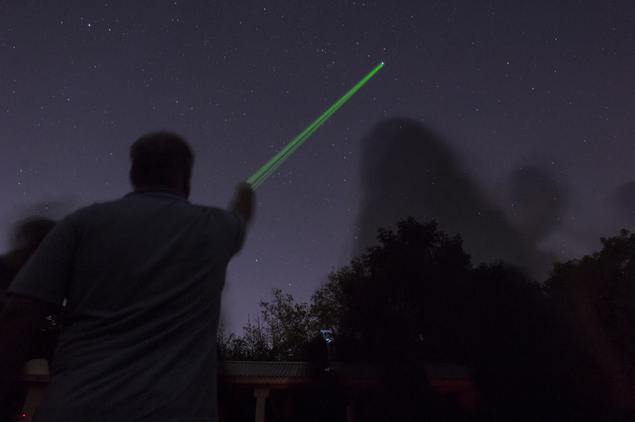

‘It made no sense’

In the summer of 1986, Tim Sofranko and three friends were killing time on a warm evening in upstate New York. They’d driven out into the country, windows rolled down, with no place to be and nowhere in particular to go. They chatted, listened to the radio, and celebrated the way teenagers do when there’s no school and no responsibilities.

The sun had set, allowing a deep darkness to settle in around them.

That’s when they saw it.

In the distance, just beyond a group of trees, there was a blinding set of white lights, rotating and blinking, but oddly, making no sound.

“Do you see that?” Tim asked from the back seat of the car.

No one responded, in part because they were all watching the strange lights, which seemed to be connected to some kind of structure. Silently, it passed over the trees and hovered away, over the horizon.

Stunned, the group couldn’t process what they’d seen.

“It was like a helicopter, I guess, but it made absolutely no noise at all,” Sofranko said, 30 years later. “I still remember it, and I still remember how we all just couldn’t figure out what we were looking at. Like – what we were seeing made no sense. I wasn’t scared, but we also didn’t go chase the thing, either. We just got out of there.”

Sofranko knew that what he saw just didn’t belong there. It’s part of what made him want to come out and hunt for UFOs.

“All these years later, I still wonder about it,” he said.

Sofranko, who lives near me in Burlington, Ky., is now a photographer. I’m a writer, and for my whole life I’ve been fascinated with the paranormal. I figured, what better way to celebrate Halloween this year than to go UFO hunting? Of course, I just had to find some scientists to go with us.

When I proposed my idea to Zoe Lee, a mechanical engineering major and astrophysics minor at Cincinnati who just happened to be the president of the school’s astronomy club, I thought she’d laugh at me. Instead, she invited me to come along to one of the group’s regular meetings, one where they’d camp out in Cleves and look at the stars.

It took me two seconds to say yes.

The Society

We loaded up our car (making sure to bring a powerful flashlight) and followed the students from UC’s campus out to Cleves, a spooky area in itself. The locals have stories about the nearby Buffalo Ridge area, where white vans chase you down if you flash your headlights at them. Others tell stories of tormented teenage lovers and haunted houses. I got it. The place looked the part.

Plus, it sits on the 39th parallel line – just around the range studied by Chuck Zukowski.

Off a deserted highway, we turned on to a gravel road that led to the headquarters of the Cincinnati Astronomical Society, which sits on four acres in the Hamilton County Park of the Mitchell Memorial Forest. There’s the small HQ building, four permanently mounted telescopes, and a satellite dish that’s been converted into a radio telescope. Outside, down a long wooded trail, the surrounding forest opens into a large clearing, where several other stations were set up by volunteers so students could look at galaxies and other heavenly bodies.

In the headquarters, Tim and I joined the group of about 50 to listen to the president of the society, Terry Endres. He explained the history of the society and set the agenda for the evening, which featured a viewing of a meteor shower at 4 a.m.

At that point it was only about 10:30 p.m., and of course, the students were excited about staying up all night.

“Sick,” one said as he gathered his backpack and sleeping bag. “This whole place is just sick.”

Endres explained that the society was officially established in 1911, and it caters to amateurs who want to learn more about things like telescope making, astronomy and stargazing. But I had to know one thing: Had Endres ever seen anything he couldn’t explain? Had he ever seen a UFO?

He hesitated for a moment, obviously wondering if I was serious.

“I’ve never seen anything I couldn’t figure out when I came back and thought about it,” he said, laughing.

Undeterred, I followed the students outside where I could look up at the stars and judge for myself.

Shooting stars

Did I really think I was going to see something? I guess not.

But I was wrong.

After watching for just 15 minutes, I saw a beautiful shooting star. An hour later, I saw another. It was like gambling in a way, or playing golf – one small win on the slot machine, or one good straight drive will keep you coming back for more. And the more I watched, the more I enjoyed myself.

In the darkness, I heard students around me taking advantage of the various telescopes. There was laughter and mingling. As the hours passed, food was delivered and it turned into a wonderful party. In short, UFO hunting was a blast – for the college students and for Tim and me.

We stayed for several hours with the group, learning more about the cosmos and taking in the peacefulness of the stars above us.

Neither of us saw anything we couldn’t explain, nor did anyone else in the group that night. But before leaving, I spied yet another shooting star, brilliant and bright, as it soared right across my line of vision. In an instant, it was gone, burned up in the atmosphere. But again, I felt lucky to have seen it – it was like someone dropped a love note from the sky, just for me.

At that moment I noticed Tim walking over to me. “Think we’ve got what we need?” he asked.

I nodded. We were ready to roll. We gathered our gear and prepared to leave when I saw a familiar face.

“Did you see anything, man?” a student asked.

I told him about the three shooting stars.

“Sick, man,” he said. “This place is just sick.”

I’d have to agree, I thought.

Pretty sick.

Epilogue

Days later, I called Chuck Zukowski to tell him I didn’t see anything unusual on my hunt.

But I told him the experience was a lot of fun.

“You get to love it,” he said. “You just keep at it, and then someday you’ll see something truly strange. You want to go back out and do it again, right?”

I admitted I did.

“That’s how it starts,” he said. “Just be careful what you wish for. You just might get it.”

Info box:
WANT TO GO UFO HUNTING?
Chuck Zukowski says there are several tips if you want to go UFO Hunting:

- Choose a clear night and have good vision of the stars
- Look toward the western sky
- Plan for at least a few hours: Most reports of odd sightings seem to occur between 10 p.m. and 1 a.m.
- Familiarize yourself with other objects in the sky, like planets, meteor showers, satellites and the International Space Station. Visit these sites: http://www.satflare.com/ and http://www.heavens-above.com/
- See something strange? Report it here: http://www.nuforc.org/

For more information about the Cincinnati Astronomical Society or memberships to the society, visit http://www.cinastro.org/

